IΔ Timed Explosive Device Analyzer

______________________________________________________________

BOMB DEFUSAL
MANUAL
______________________________________________________________

Version 2.16
Code: 14092024

Welcome to the art of bomb defusing.
Read this manual carefully. You will find all information you need to safely defuse even the most complex bombs.
But be careful the smallest error can have explosive results!

BOMB DEFUSION MANUAL
FOR ARDUINO BALLOON BOMB
Works in conjunction
with VirtualPanel
Alias:
“Timed Explosive Device Analyzer”

Inspired by / based on the game “Keep talking and nobody explodes”.
Built and published as Arduino DIY project by Jaap Daniëlse.
This project is published under GNU license.

Introduction
Balloon Bomb is an escape room like puzzle game.
It is derived from a well-known online game “Keep talking and nobody explodes”.

The bomb has as “explosive” a balloon that is punctured by a pin if time has expired or too many mistakes have been made.
A loud pop, but otherwise harmless.

The bomb must be defused by teamwork.
One or two of the participants sit with the PC and the bomb and the other team members, at a distance, hold the dismantling manual.

The game is mainly about communicating efficiently. The participants at the PC and bomb indicate which module is to be played, and the participants with the manual then look up what is to be done and tell that to the players at the PC and bomb.

The timer starts at a high number but as soon as the bomb is connected to the PC software the counter changes to a time depending on the complexity of the bomb. It is advisable to read the first parts of the manual before this.

Good luck and have fun!

Defusing Bombs
Read these instructions carefully!

A bomb will explode when its countdown timer reaches 0000 or when too many strikes have been recorded. The only way to defuse a bomb is to disarm all its modules before its countdown timer expires.

Connecting the analyzer
To analyze the bomb, you will need to connect a PC with the Timed Explosive Device Analyzer (TEDA) software.
For this you need a USB-A to USB-B cable.
When this connection is made double click the TEDA icon to start the analyzer.
When the Analyzer software connects to the bomb the counter will be set to a remaining time depending on the bomb configuration.

Modules
A bomb will typically have 2 to 5 modules. The modules are shown in the Analyzer panel with buttons marked [mod A],
[mod B] etc. Pressing one of these buttons will show the module panel.
To defuse the bomb all modules must be disarmed.
A disarmed module will be indicated with a green led.

Strikes
When the defuser makes a mistake, the bomb will record a strike which will be displayed in the Analyzer panel.
The timer will begin to count down faster after a strike has been recorded.
When a third strike is recorded the bomb will explode.

Finding information
Some disarming instructions will need specific information about the bomb, such as the serial number. This type of information can typically be found on outside of the bomb casing.
Additional information can be found on the analyzer display.

Section 1 Timed Explosive Device Analyzer

After connecting the bomb to the Analyzer, the top panel depicted below will appear.

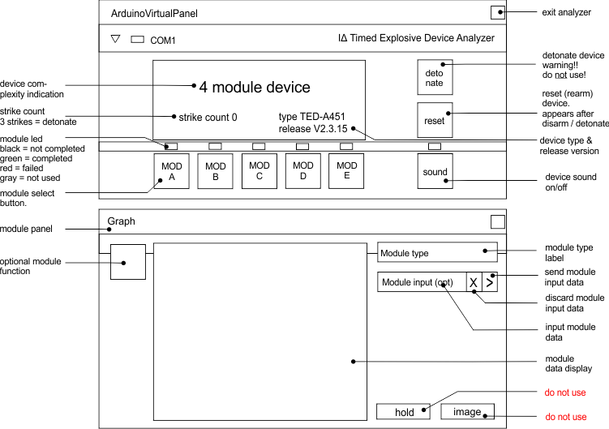

The display’s top line indicates the device complexity in terms of the number of modules.
Below this (left) is the strike count. On the third strike the device will explode.
Same level right you see the device type and the software release version. The version may be a factor in the module solving.
The detonate button is self-explanatory. Do not click!
The sound button can be used to switch off the sound of the timer click.
On the bottom you see module-buttons (MOD). When grayed out they are not active. Clicking one of the mod-buttons will activate module panel (bottom) showing the module data.
The module type is shown top right. Other buttons or inputs may appear depending on the module. If present these are described in the module section.
The hold and image buttons are not intended for use with the analyzer. Do not use. They can disrupt the Analyzer function.

Section 2 Modules

Depending on the device type there can be between 2 and 5 modules.
All modules must be solved to defuse the device.
If you make a mistake, the device will record a strike which will be displayed in the analyzer display (bottom left).
The bomb will explode on the third strike.
Some modules will not record a strike, but detonate immediately when failed. The analyzer will indicate this.
In the sections below each of the modules is described.
On the top right you will see an image of the module display to help you identify the module.

Wire connection module
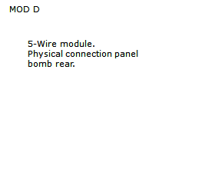
A wire module is a physical module on the outside of the bomb.
The analyzer can identify the presence of the module and the number of wires but not their color.

!! WARNING This module detonates on
failure Directly!

- A wire module can have 4–6 wires.
- When needed connectors can be removed to break a connection.
- Wire ordering is from left to right.
- Depending on the bomb release version a specific reconnection needs to be made.
- Some connections can only be done when the timer is at a specific value interval.
- When reconnection is required be careful not to make contact prematurely!

3-Wire module
- The connectors will be blue, red and yellow from left to right.
- If the serial number is odd, remove the yellow connector when the counter is divisible by 3.
- If the serial number is even, remove the red connector when the counter is divisible by 5.

The module should be solved.

4-Wire module
- The connectors will be green, blue, red and yellow from left to right.
- If the serial number is odd, remove the yellow connector when the counter is divisible by 3.
- If the serial number is even, remove the red connector when the counter is divisible by 5.

The module should be solved.

5-Wire module

If the release (sub) version is odd and ...
- the last connector is yellow, remove the fourth connector when the counter is even.
- the last connector is black, remove the second conn.
- the last connector is blue, remove the green conn. when the counter is divisible by 3.

Next
- If the green connector has been removed, remove the blue connector.

Next
- If there is a black connector remove this when the counter is divisible by 5 and reconnect it to the blue inlet.

The module should be solved.

If the release (sub) version is even and ...
- the last connector. is black, remove the second conn.
- the second connector is red, remove the first conn.
- the last connector is blue, remove the green connector when the counter is divisible by 3.

Next
- If the black connector has been removed, remove the blue connector when the counter is even.

Next
- If there is a green connector remove this when the counter is divisible by 5 then reconnect it to the blue inlet.

The module should be solved.

6-Wire module
- If the release (sub) version is odd and the last wire is green, remove the third connector.
- If the release (sub) version is odd and the last wire is yellow, remove the second connector.
- If the release (sub) version is even and the last wire is blue, remove the green connector when the counter is divisible by 2.

Next
- If the yellow connector has been removed, remove the blue connector when the counter is even.

Next
- If there is a black connector remove this and reconnect it to the blue inlet when the counter is divisible by 3.

The module should be solved.

Morse Code Module

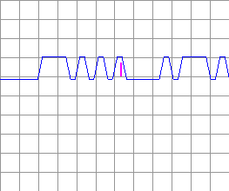
Interpret the signal from the bar using the Morse Code chart to spell one of the words in the table.
The signal will loop, with a long pause between repetitions.
Once the word is identified, type the corresponding response in the input field and press enter.
Or click ▷

How to interpret
- A short bar represents a dot.
- A long bar represents a dash.
- There is a pause between letters.
- There is a long pause before the word repeats.

Morse Code Chart

A .-
B -...
C -.-.
D -..
E .
F ..-.
G --.
H ....
I ..
J .---
K -.-
L .-..
M --
N -.
O ---
P .--.
Q --.-
R .-.
S ...
T –
U ..-
V ...-
W .--
X -..-
Y -.--
Z --..
0 -----
1 .----
2 ..---
3 ...--
4 ....-
5 .....
6 -....
7 --...
8 ---..
9 ----.

Word | Response | Word | Response | Word | Response
label | AA-12 | major | BF-67 | loose | CK-92
ashes | AB-23 | level | BG-78 | minor | CL-93
robot | AC-34 | noise | BH-89 | trick | CM-94
shape | AD-45 | clock | BI-90 | mines | CN-95
cheer | AE-56 | naval | BJ-01 | stops | CO-96

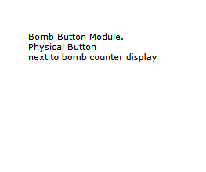
Bomb Button Module

On the device is a button.
Follow the rules listed below.
Perform the first action that applies.

- If the button is blue and says “HOLD” refer to “Releasing a held button”.
- If the button is green and unmarked refer to “Releasing a held button”.
- If the button is yellow, unmarked and the release version is even, release the button directly.
- If the button is red and says “detonate” refer to “Releasing a held button”.

Releasing a held button
If you start holding the button down a colored band will appear in the module screen. Based on its color, you must release the button at a specific point in time:

Band color | Action
Blue | release when the countdown timer has a 7 in any position.
Orange | release when the countdown timer has a 4 in any position.
Yellow | release when the countdown timer has a 3 in any position.
Any other | release when the countdown timer has a 1 in any position.

Circuit Board Module

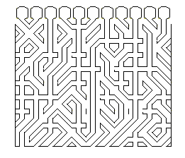
The module shows a diagram of one of the bombs circuit boards.
To complete this module, you must disable the edge connector tracks as indicated.

On top you see the board edge connector with a total of 11 tracks.
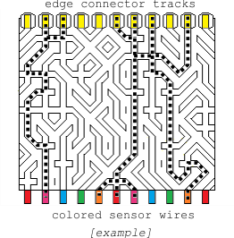
On the bottom you see the colors of sensor wires attached to the board.
Identify the circuit board tracks which connect from top to bottom directly. See dotted lines in example.
For each of these tracks, verify which of the colored wires (bottom) are connected to each other.
Use the table below to determine which action to take.
You can disable a circuit board edge connector track (on top) by clicking on it. You can enable it by clicking again.
When disabling an edge connector track, all other connected tracks must also be disabled!
When you have the right configuration press [send].

Wire Colors: B=Blue, G=Green, O=Orange, P=Pink, R=Red.

0/1 wire color 2 wire colors
wire  color | letter |  | wire  colors | letter
- - - - - | K |  | - - - P R | D
 |  |  | - - O – R | D
- - - - R | K |  | - G - - R | K
- - - P - | R |  | B - - - R | D
- - O - - | K |  | - - O P - | D
- G - - - | D |  | - G - P - | D
B - - - - | R |  | B - - P - | K
 |  |  | - G O - - | K
 |  |  | B - O - - | D
 |  |  | B G - - - | D

3 wire color 4/5 wire colors
wire  colors | letter |  | wire  colors | letter
- - O P R | D |  | - G O P R | D
- G - P R | D |  | B - O P R | D
- G O – R | D |  | B G - P R | D
- G O P - | D |  | B G O – R | D
B - - P R | D |  | B G O P - | D
B - O – R | D
B - O P - | D |  | B G O P R | D
B G - - R | D
B G - P - | K
B G O - - | D

When disabling an edge connector track, all other connected tracks must also be disabled!

Letter | Instruction
D | Disable connector.
K | Keep connector enabled.
R | Disable if serial nr. is even.

Button order Module

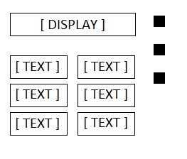
- Read the display and use step 1 to determine which button label to read.
- Using this button label, use step 2 determine which button to push.
- Repeat until the module has been disarmed.

Step 1:
Based on the display, read the label of the indicated button and proceed to step 2:
UP |  |  | DOWN |  |  | LEFT |  |  | RIGHT |  |  | STOP |  |  | ADD
👁️ |  |  |  |  |  |  |  |  |  | 👁️
 |  |  | 👁️ |  |  |  |  |  |  |  |  |  | 👁️
 |  |  |  |  |  | 👁️ |  |  |  |  |  |  |  |  |  | 👁️

PLUS |  |  | START |  |  | ENTER |  |  | DEL |  |  | OFF |  |  | BACK
👁️ |  |  |  |  |  |  |  |  |  | 👁️
 |  |  | 👁️ |  |  |  |  |  |  |  |  |  | 👁️
 |  |  |  |  |  | 👁️ |  |  |  |  |  |  |  |  |  | 👁️

Step 2:
Using the label from step 1, lookup the label in the left column and push the button which label appears first in the corresponding list on the right:
UP | DOWN, LEFT, RIGHT, STOP, ADD, PLUS, START, ENTER, DEL, OFF, BACK
DOWN | LEFT, RIGHT, STOP, ADD, PLUS, START, ENTER, DEL, OFF, BACK, UP
LEFT | RIGHT, STOP, ADD, PLUS, START, ENTER, DEL, OFF, BACK, UP, DOWN
RIGHT | STOP, ADD, PLUS, START, ENTER, DEL, OFF, BACK, UP, DOWN, LEFT
STOP | ADD, PLUS, START, ENTER, DEL, OFF, BACK, UP, DOWN, LEFT, RIGHT
ADD | PLUS, START, ENTER, DEL, OFF, BACK, UP, DOWN, LEFT, RIGHT, STOP
PLUS | START, ENTER, DEL, OFF, BACK, UP, DOWN, LEFT, RIGHT, STOP, ADD
START | ENTER, DEL, OFF, BACK, UP, DOWN, LEFT, RIGHT, STOP, ADD, PLUS
ENTER | DEL, OFF, BACK, UP, DOWN, LEFT, RIGHT, STOP, ADD, PLUS, START
DEL | OFF, BACK, UP, DOWN, LEFT, RIGHT, STOP, ADD, PLUS, START, ENTER
OFF | BACK, UP, DOWN, LEFT, RIGHT, STOP, ADD, PLUS, START, ENTER, DEL
BACK | UP, DOWN, LEFT, RIGHT, STOP, ADD, PLUS, START, ENTER, DEL, OFF

Section 3 (Re)setting the bomb

Reset for the next try
After “– device disarmed –” or “– device detonated –” a reset button will appear below the detonate button.

- On the wire panel (back of the bomb) reconnect all connectors to the correct inlets.
- If needed inflate a new balloon inside the bomb housing.
- Press the reset button to reset the device.

Reset to level 1
When the PC is disconnected or the TEDA software switched off press the green button.
The display will show -L1- briefly and count from 9999.

Setting level manual
If you want to set the bomb to a specific level press the ▼ button on the upper left corner of the TEDA panel (when connected to the bomb).
Select monitor from the dropdown.

In the “level” input replace the current level with the desired level and press the input’s ▶ button.

The device will reset with the set level.
This is also saved.

Setting modules and time manualy
When level 0 is selected when Setting level (above) you have control over the time and the selected modules.

For time enter a desired value in the “counter” input and press the input’s ▶ button.

For modules enter the letters (A,B,C,D,E no spaces or commas) of the desired modules in the “modules” input and press the input’s ▶ button.
Valid letters are A,B,C,D,E. Enter the letters in capital and without spaces. “ACE” is a valid entry.

n.b. You need to press the ▶ button for each value separately and wait for the reset.

BOMB DEFUSION MANUAL
FOR ARDUINO BALLOON BOMB

